NDIVHUWO WANDILE RANWEDZI

ST10442454

wede5020

POE-Part 1&part2

ST10442454

WEB DEVELOPMENT (WEDE5020) *[process document]*

Part 1& Part 2

RANWEDZI NDIVHUWO WANDILE

Table of Contents

WEBSITE CHOICE………………………………………………………………………………………………………………………………4

WEBSITE ASSETS 4

WEBSITE ASSETS(part 2) 11

References 16

WEBSITE CHOICE

  Eagle eye photography studio

                                 “*your memories ,our masterpieces*”

**DESCRIPTION OF MY WEBSITE**

I chose a small  local business called “Eagle eye photography studio” .Eagle eye  in terms of photography refers to a photographer’s exceptional attention to detail and ability to notice even the smallest elements in a scene. This skill is crucial for capturing high-quality images, as it ensures that every aspect of the photo is carefully considered and composed.

The main reason of this business is  personalized service and community connection the studio offers, as  local photographers have a deep understanding of the area’s unique characteristics, which can be reflected in their work ,making the photos more meaningful and relevant. And for  helping   fellow friends and families capture important milestones.

Eagle eye photography make  use of premium materials for prints and albums, ensuring lasting memories , Providing beautiful prints and albums that can be cherished for years.it also helps friends and families preserve precious moments through professional photography .Eagle eye photography uses visual storytelling to raise awareness about important social issues ,driving community engagement and actions, This business do offer workshops and classes ,sharing photography skills and knowledge with the community.

The benefits of this studio are as follows : providing  a professional and controlled environment for capturing high-quality images, ensuring that special moments are preserved beautifully. By supporting a local studio, community members contribute to the local economy, fostering economic growth and creating job opportunities. The personalized service and deep understanding of local culture and tradition enhance the overall client experience .

I am developing this website to help the business establish a strong online presence.The website will help the studio to showcase their portfolio,attract new clients and provide essential information as services offered ,pricing and contact details .This website will help increase visibility ,the ablility to reach a broader audience and the convenience for potential clients to view and book services online. Additionally, a well-designed website can enhance the studio’s professional image and credibility, making it easier to compete with other studios.

**REASON I CHOSE EAGLE EYE PHOTOGRAPHY BUSINESS**

In conclusion . I chose Eagle eye photography because   I believe in the power of local businesses to enrich our community. Eagle Eye Photography, with its exceptional attention to detail and personalized service, stands out as a beacon of quality and creativity. By building a website, I aim to showcase their stunning portfolio, making it accessible to a broader audience and attracting more clients. The website will also serve as a platform for community engagement, highlighting local events and collaborations.

# WEBSITE ASSETS

**INFORMATION ABOUT THE BUSINESS[EAGLE EYE PHOTOGRAPHY]**

* The main reason of this business is  personalized service and community connection the studio offers, as  local photographers have a deep understanding of the area’s unique characteristics, which can be reflected in their work ,making the photos more meaningful and relevant. And for  helping   fellow friends and families capture important milestones.

**WEBSITE INSPIRATION**

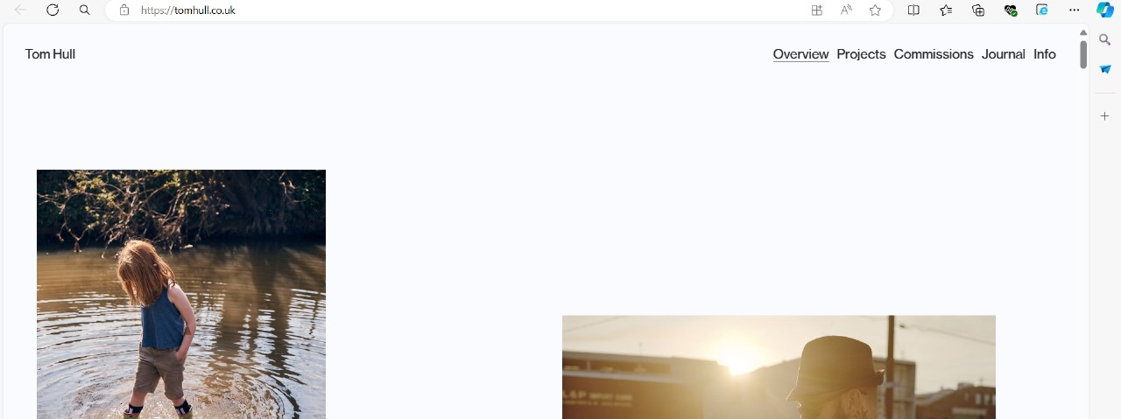

**IMAGES AND APPS ,WEBSITES USED FOR MY WEBSITE**

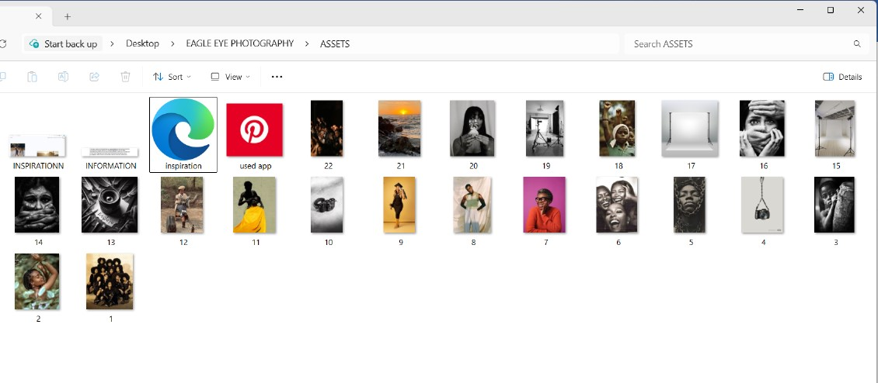

**IMAGES**

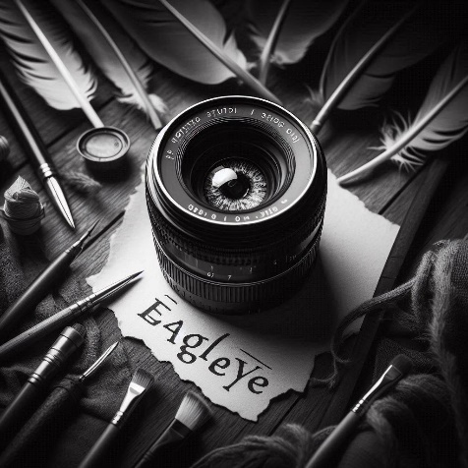 **[ logo**] figure 1: (RANWEDZI.N.W., 2024)

 figure 2 : (Anon., 2024) 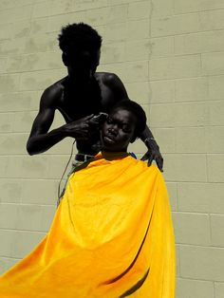 figure 3: (Anon., 2024)

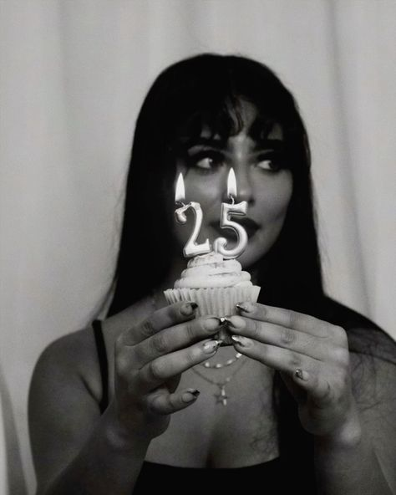 figure 4: (https://www.pinterest.com/pin/1337074887852830/, 2024)

 figure 5 : (pinterest, 2024)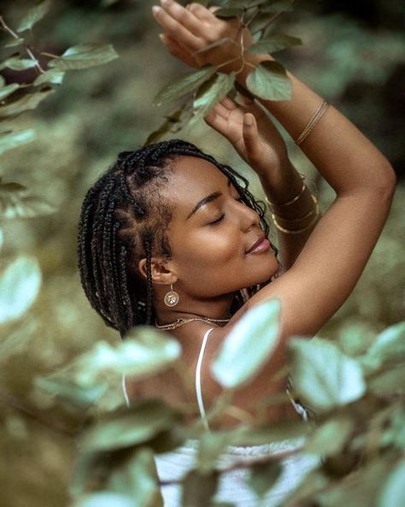 figure 6 : (pinterest, 2024)

 figure 7: (pinterest, 2024) 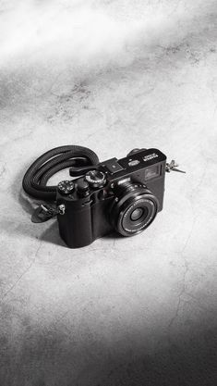 figure 8: (pinterest, 2024)

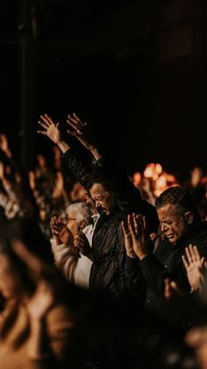 figure 9: (pinterest, 2024) figure 10: (pinterest.com, 2024)

 figure 11: (pinterest, 2024) 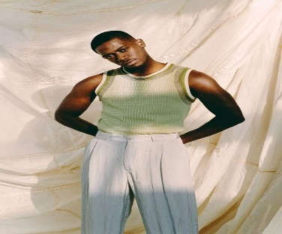

figure 12: 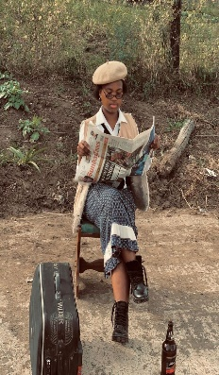 figure 13 : (pinterest, 2024)  figure 14 : (Anon., 2024)

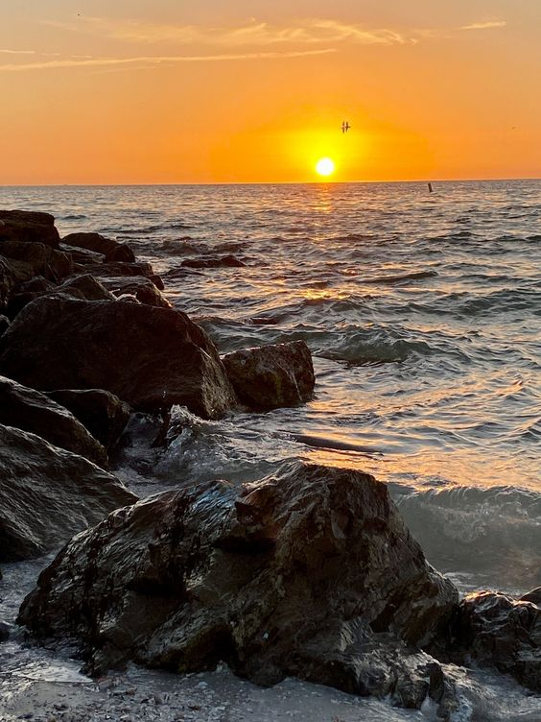 figure 15 :  figure 16: (pinterest, 2024) (pinterest, 2024)

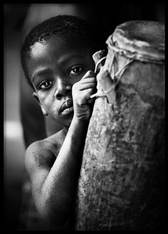 figure 17: (pinterest, 2024)  figure 18 : (pinterest, 2024)

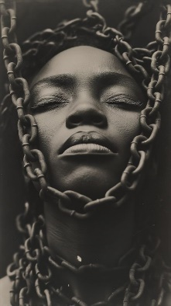 figure 19 : (pinterest.com, 2024)

WEBSITE PAGES & CONTENT

Homepage :

* Logo& slogan
* Links to other pages
* Summary about the eagle eye photography
* Some of the business’s portraits
* Copyright & year

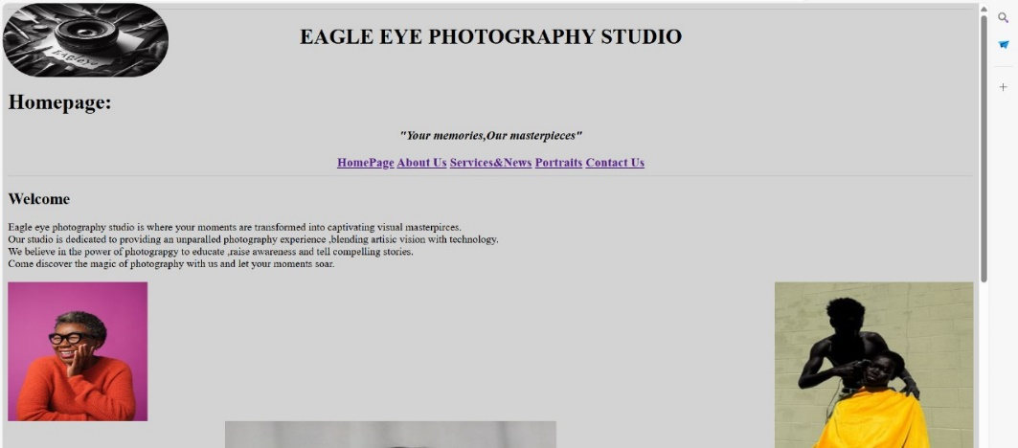

About us:

* Our purposes

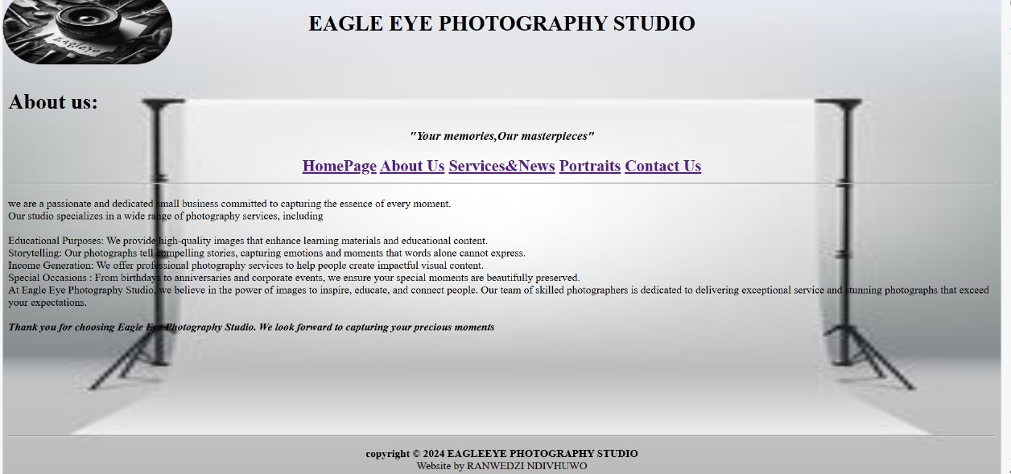

Services&News :

* Parties
* Graduations
* Gatherings
* Indoor & outdoor photoshoot
* News: special offers ,stay updated ,photography ideas..etc

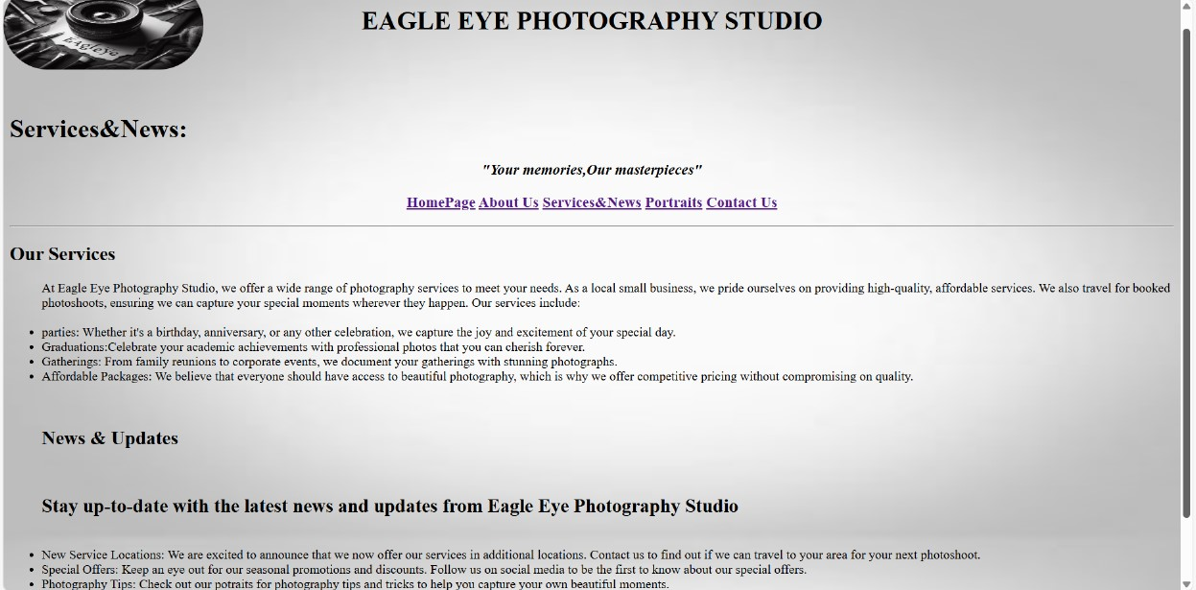

Portraits :

* Our portraits ,our amazing work

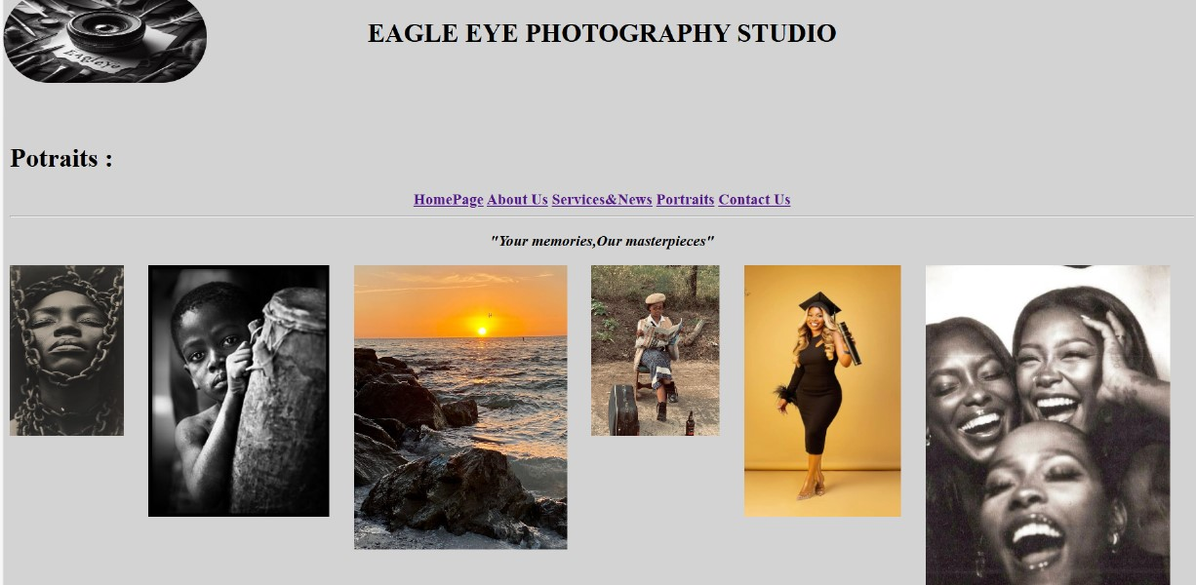

Contact us :

GET IN TOUCH

* Email
* Instagram
* Facebook
* Whatsapp
* Telephone number
* Cell number

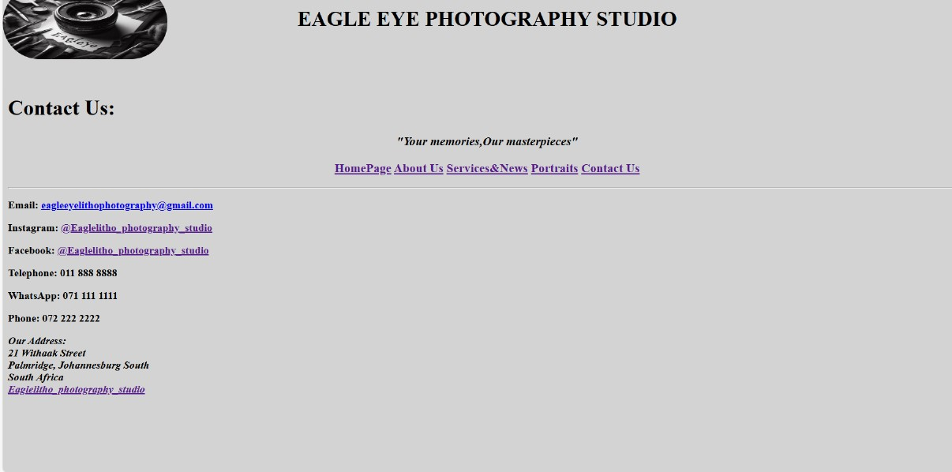

**PART 2**

1. **Improvements to the PART 1 PROCESS DOCUMENT**

# WEBSITE ASSETS

**IMAGES AND APPS ,WEBSITES USED FOR MY WEBSITE**

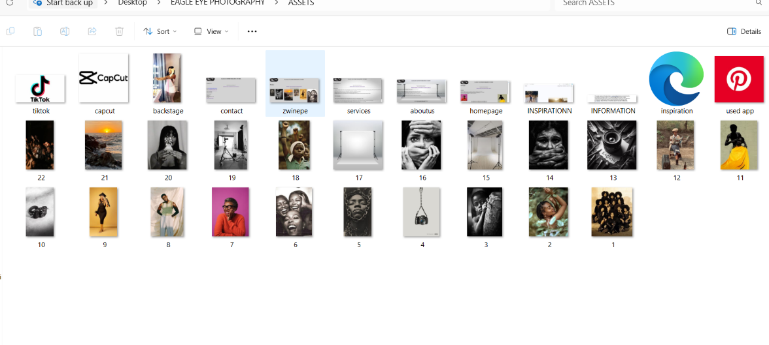

-I added tiktok,capcut and a video

WEBSITE PAGES

Homepage :

* Logo& slogan
* Links to other pages
* Summary about the eagle eye photography
* Some of the business’s portraits
* Copyright & year

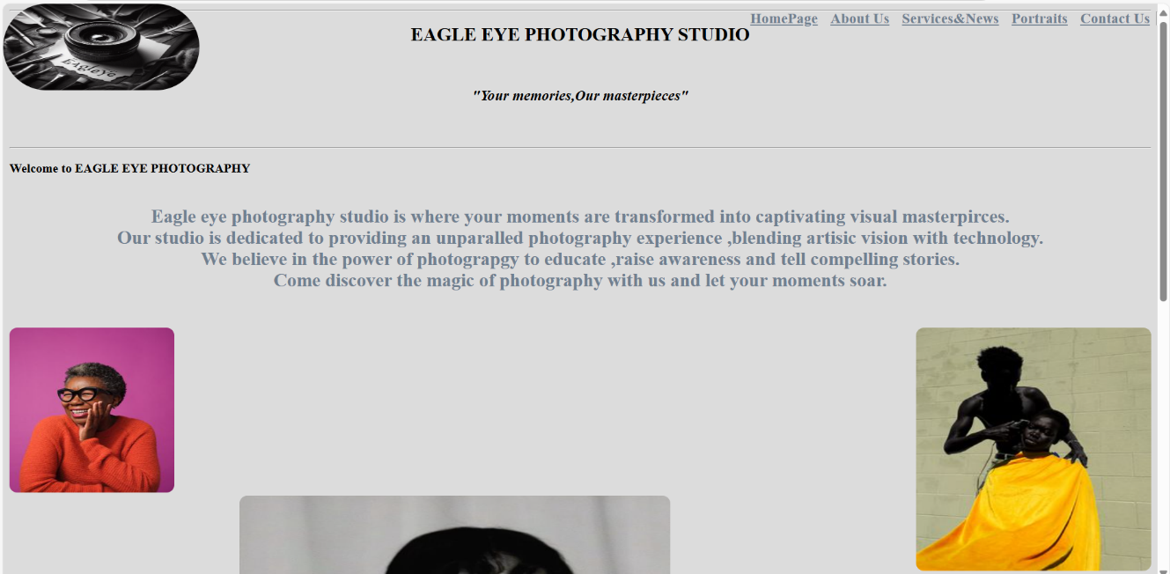

* I changed the position of my navigation bar from center ,to top right.

About us:

* Our purposes

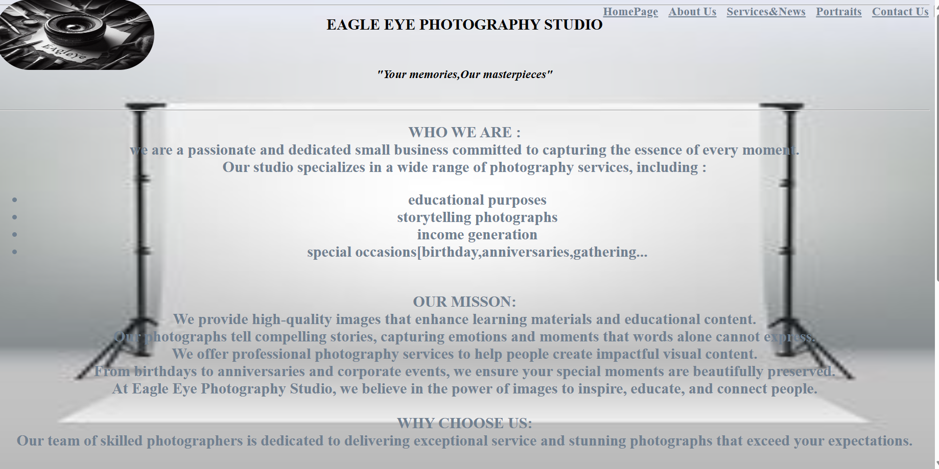

* I changed the position of my navigation bar from center ,to top right.

Services&News :

* Parties
* Graduations
* Gatherings
* Indoor & outdoor photoshoot
* News: special offers ,stay updated ,photography ideas..etc

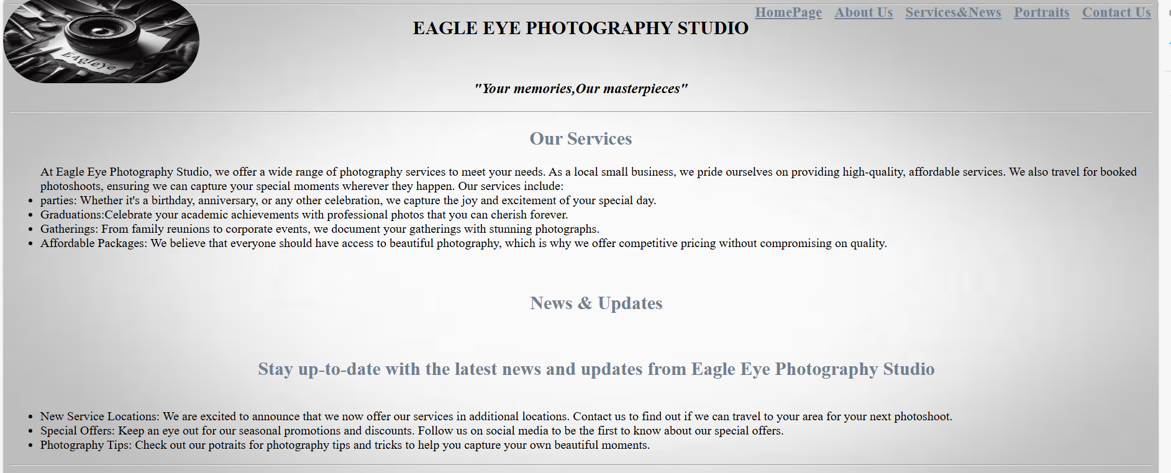

* I changed the position of my navigation bar from center ,to top right.

Portraits :

* Our portraits ,our amazing work

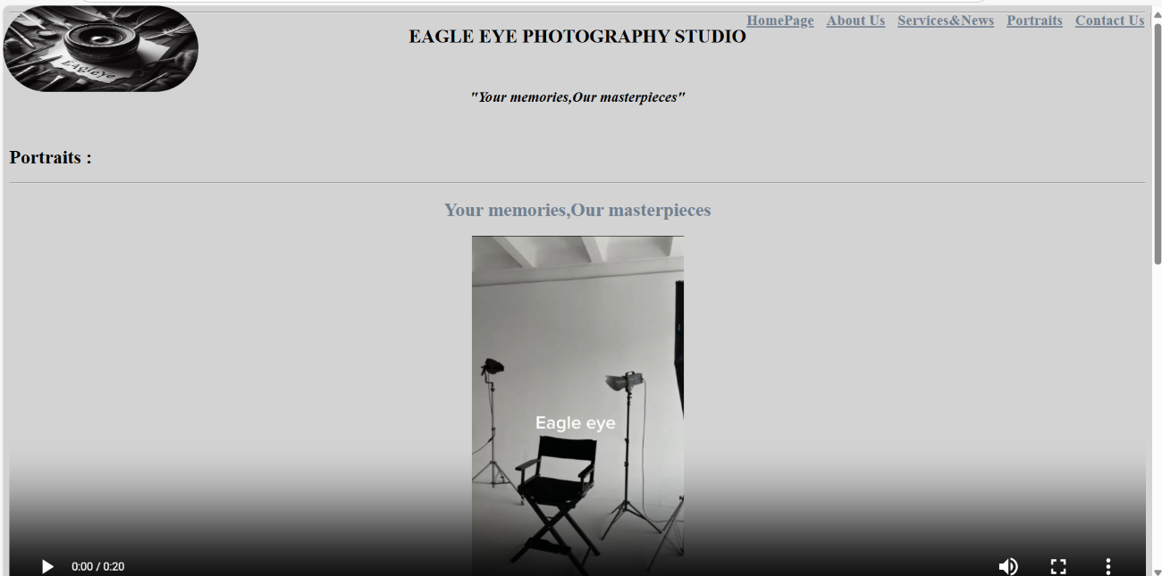

* I changed the position of my navigation bar from center ,to top right.
* I inserted a video of what it looks like in our studio

Contact us :

GET IN TOUCH

* Email
* Instagram
* Facebook
* Telephone number
* Whatsapp
* Cell number
* Our physical address

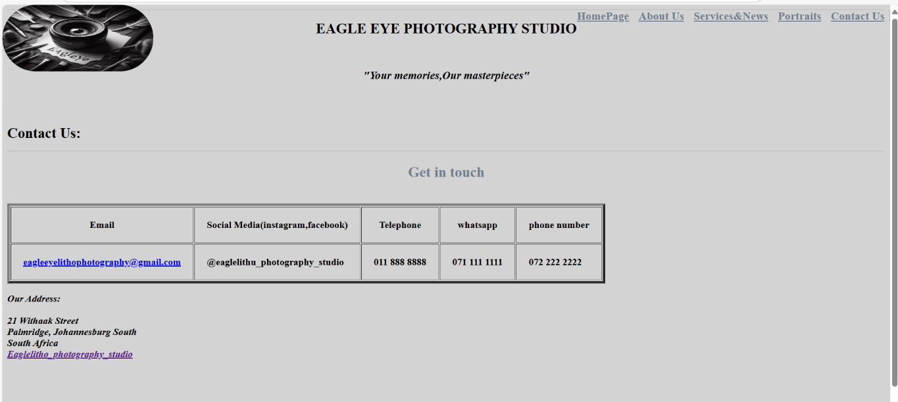

* I changed the position of my navigation bar from center ,to top right.
* This time around used a table to categorize my contact information .

1. **Improvements to the PART 1 WEBSITE**

* I changed the position of my navigation bar using Css style sheet to link all of my webpages ,from <center></center> to top right of all my WEBPAGES ,to make it more accessible and intuitive for users, especially on larger screens and that For mobile devices, a top-right navigation bar can be more adaptable.
* I changed my to Tahoma, sans-serif; and Calibri, sans-serif;
* I changed the color of all my < h2 > to be Gainsboro ,because black was too dual and I want my website to be vibey as it is a Photography studio website ,I applied Gainsboro color in each and every webpage because I love uniformity and order.
* In homepage I shifted my <p> to be at the center because  I want to improve the visual layout and readability of the content. I also added basic contact so that it is easy for visitors to find your contact details without having to navigate through multiple pages.
* In About us webpage ,i divided my information under their related subtopics ,using <center></center>and color;gainsboro,<h2></h2>, I also added our working hours and days and added a rotating text to make it more interesting .
* In Services & News webpage I only changed the postion and the color of my <h2>,then the <p> was not changed.
* In Portraits webpage I inserted a video to show the backstage of our photography studio looks,all the fun and setup , because A video can demonstrate the photographer’s expertise and style in a dynamic way, highlighting their ability to capture emotions and moments effectively and also tell a story more effectively than photos alone. They can convey the atmosphere, emotions, and narrative behind the portraits, making the work more relatable and memorable.
* In Contact us webpage ,I change the contact information in a form of a <table > to help organize data in a clear and structured way, making it easier for users to read and understand

LIST OF REFERENCES

# References

Anon., 2024. *https://www.pinterest.com/.* [Online]   
Available at: https://www.pinterest.com/pin/726768458631935192/  
[Accessed 25 AUGUST 2024].

Anon., 2024. *pinterest.com.* [Online].

https://www.pinterest.com/pin/1337074887852830/, 2024. *pinterest.com.* [Online]   
Available at: https://i.pinimg.com/474x/51/7a/14/517a149f734426491d2a584fa373e7ce.jpg  
[Accessed 25 AUGUST 2024].

pinterest.com, 2024. *https://www.pinterest.com/.* [Online]   
[Accessed 25 AUGUST 2024].

pinterest.com, 2024. *pinterest.* [Online]   
Available at: https://i.pinimg.com/564x/04/18/eb/0418eb2f66fef2acdc2297c38cdc6722.jpg  
[Accessed 25 AUGUST 2024].

pinterest, 2024. *pinterest.com.* [Online]   
Available at: https://www.pinterest.com/pin/1128855462841444504/  
[Accessed 25 AUGUST 2024].

pinterest, 2024. *pinterest.com.* [Online]   
Available at: https://www.pinterest.com/pin/61572719899903437/  
[Accessed 25 AUGUST 2024].

RANWEDZI.N.W., 2024. [Online]   
Available at: cover picture.jpeg